2017
EVALUATIONS OF TEACHING
Considerations for Faculty

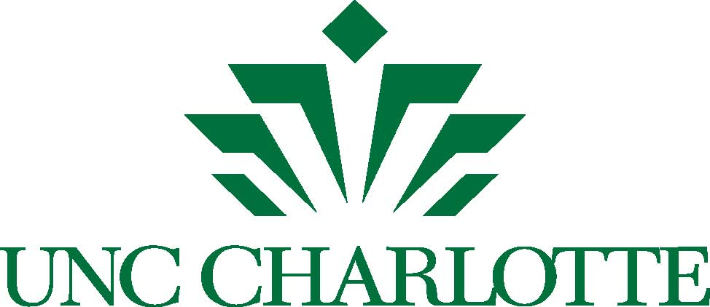

Office of Academic Affairs

August 2017

Dear Faculty,

The term “teaching evaluation” readily calls to mind the end of course surveys completed by students just before final exams. As they are often used, these surveys provide a check on student satisfaction with a course and may be used as a proxy for teaching effectiveness in evaluations of faculty for salary increases, reappointment and promotion. The surveys provide a voice for students, but when used alone and without context, they do not serve students, faculty, or administrators particularly well. The information in this document was compiled by a group of experienced faculty and staff to assist you in getting the most out of evaluations of teaching to the benefit of both you and your students. I hope you will take the time to read this and make use of the advice provided.

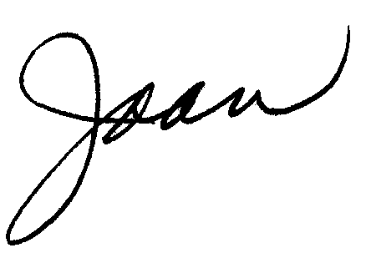
With my best wishes for a successful year,

Joan F. Lorden
Provost and Vice Chancellor for Academic Affairs

Committee Members
Garvey Pyke
Lori Gossett
Yvette Huet
Charles Houck
Mary McKenzie
Tracy Rock
Robert Russell

I. Using Student Evaluations

Why are student evaluations important?
In addition to giving students a voice in their instruction, the primary goal of any evaluation of teaching is to improve instruction. For the process to be useful, faculty need to think about what questions students can reasonably answer, review the data received, and after careful consideration of the responses, use it for development and improvement of their teaching. Evaluations can help a faculty member create the best educational experience for their students.
In the appropriate context, student evaluations of teaching can also provide evidence of a faculty member’s growth and expertise as an educator.

What improves student responses in teaching evaluations?
According to a study involving 200 faculty respondents (McGowan & Graham, 2009), the following four factors contributed to the improvement of teaching as measured in student evaluations:
- Engaging in active and practical learning that emphasizes the relevance of course material to students.
- Creating the opportunity for significant teacher/student interactions and conferences that allow instructors to connect with students.
- Emphasizing learning outcomes and setting high expectations.
- Revising and improving how student learning is assessed.

What are the best ways for an instructor to use data from student evaluations of teaching?
1. Carefully consider the data. Faculty should pick a time to review their student evaluations when they have enough time to not only read the evaluations but give them careful consideration. Consider how the evaluation’s numerical data fits your own teaching goals and what our institution expects from our faculty. Remember that many factors can influence responses. For example, there may be some variation in student responses in teaching evaluations for required versus elective courses.

2. Review the comments and note trends among the comments. Patterns over time or across your courses will give you the most useful information and should be weighed most heavily. For any single course, compare the comments of students who gave the course a very positive evaluation with the comments of students who gave the course a less positive evaluation. Also, note comments that are appearing more than once but perhaps not as often as other comments. These may help identify an issue that concerns a subpopulation of your students. Note what students think you did well and not only those areas they note as needing improvement.

3. Don’t go it alone. Research has shown that reviewing student evaluation data in a follow-up consultation is more likely to result in positive modifications in teaching and course design that can influence future evaluations (Murray, 1997). Discussing your thinking with a colleague or a teaching consultant before making significant changes to your course will save you time. If there are areas in which you need improvement, determine how you can get help in those areas (e.g., professional development workshops or a one-on-one meeting with someone from the Center for Teaching and Learning, discussing teaching methods used by other faculty in your department who have had success with changes you wish to make, et cetera). We recommend contacting UNC Charlotte’s Center for Teaching and Learning via the website (http://teaching.uncc.edu/) to arrange an individual consultation to review and interpret student feedback.

You can also start conversations with your colleagues about how they handle situations that you may be struggling with. Have a trusted colleague read the evaluations and provide perspective. Or just ask about how they handle something that may be a problem for you. For example, you might ask how they know whether or not students are following them or whatever else you suspect may be hard for you. Although faculty may not begin conversations on teaching often, most happy to engage in one once you start it.

How should faculty document their use of student evaluation data and why?
Faculty should respond to issues they see in their student evaluations by documenting the issues and their plans to address them (e.g., workshop, change in course format).

A good technique for faculty to use to track area(s) of needed improvement is the development of a Teaching Enhancement Plan (TEP). The TEP is a document that allows faculty to identify an area of focus/inquiry for enhancing their teaching practice based on data that they have received (i.e., student evaluations, peer observations, self-analysis, reflection on their teaching) and create a plan of action for next semester or next academic year to examine this aspect of their teaching and work to improve it. The action steps might include gathering resources and readings; self-analysis through videotaping; observations of other faculty; engaging in learning communities with other interested faculty members; or participating in professional development opportunities and workshops available through professional societies, the university’s Center for Teaching and Learning, or college and departmental offerings. Faculty can use the TEP to identify outcomes and reflect on the action plan before designing next steps or new goals. This document can be submitted as part of the annual review and with reappointment or promotion and tenure documents to provide evidence of how the faculty member engages in the continual improvement of their teaching practice.

What does it mean for an instructor to show progress?
When teaching evaluations are a part of the faculty member’s annual evaluation or evaluation for reappointment or promotion and tenure, progress documented through a TEP demonstrates their commitment to quality teaching. Faculty can summarize data from previous years’ evaluations to demonstrate that changes were made and that there were outcomes attributable to the changes. Improvement can be shown by the changes in student comments over time (e.g., initially many students discussed lack of timely communication, and more recent evaluations do not identify this as a problem).

Progress can also be documented with the peer observation of teaching. Faculty can communicate in a pre-observation conference the areas within their practice they have been working on based on data from student evaluations or previous peer evaluations. They can ask the current peer observer to take note of this aspect of their practice for any changes or improvements observed during a class session. Changes over time in their student evaluation data and/or peer observation data help to make the case that teaching has improved.

II. Beyond the
End-of-Term Survey

Can faculty implement their own mid-semester evaluation and why would they?
Many faculty choose to collect some data from their students during the semester instead of waiting until the end of the course. This is an opportunity to better understand students’ needs and to monitor how they are responding to particular course activities, teaching methods, class materials, or use of instructional technology. By gathering information during the semester, the instructor has the opportunity to make corrections to the course while it is still happening. Students recognize and appreciate faculty efforts to improve a course while they are taking it.

Just as early alerts help students adjust, we suggest that all faculty would benefit from getting student feedback about their courses early in the semester. The methods chosen are up to the faculty member and can be tailored to the course.

Making micro-changes within the term versus macro changes between semesters?
Student evaluations conducted during the semester can provide guidance an instructor can use to make small but impactful changes (e.g., how or when you provide feedback on student assignments, projecting your voice to the back of the classroom, and so on). Larger changes may have to wait for the next time you teach the class (e.g., textbook selection, revisions to major assignments that had unclear outcomes).

What should instructors say to their students regarding mid-semester feedback?
When making changes mid-semester, you may want to discuss the changes with the class and allow students to comment. This demonstrates that you are interested in what and how they are learning and serious about responding to information they have provided. However, you will also want to report back to your students on the evaluation itself. The following are tips to assist you as you engage in reviewing the feedback you have received:

1. Consider carefully what students say. First, look over the positive things your students have said about the course. This is important because it is too easy to get consumed by the negative comments. Then read their suggestions for improvement and group them into three categories:

- Those you can change this semester (e.g., the turnaround time on homework assignments).
- Those that must wait until the next time the course is offered (e.g., the textbook).
- Those that you either cannot or, for pedagogical reasons, will not change (e.g., the number of quizzes or tests).

Should you decide to make changes within the semester, you might consider making small, modest changes. Also, do not give up on a change the first time it does not seem successful. Tinker with it, making little adjustments, and see if it can be made successful after all. Improvement in teaching, like anything else, takes practice. Second, even though one student's suggestion can seem especially insightful, be careful of investing too much significance in any single response. You should be looking for patterns within the data and concentrating on the issues that seem problematic for large number of students or for a group of students with particular needs. Try not to take it to heart if one or two students are especially critical. Every teacher has these experiences with students at some time or another, and the reasons for their discontent could lie within themselves. However, even if only one or two students tell you that the classroom environment feels hostile or non-inclusive, take this feedback seriously and address it promptly.

2. Let students know what will or will not change as a result of their feedback. Students appreciate knowing that an instructor has thoughtfully considered what they have reported. Clarify any confusions or misunderstandings about your goals and their expectations. Then review which suggestions you will act upon immediately, which must wait until the course is next offered, and which you will not act upon and why. Let students know what they can do as well. For example, if students report that they are often confused, invite them to ask questions more often. Also, remind them to take advantage of the office hours for individual consultations and support. Keep your attitude and tone neutral; avoid being defensive, indignant, or overly apologetic.

3. Select a method for responding to student feedback that works for you. You may simply discuss the results with the class as a whole. You could also provide a handout of salient responses to questions or prepare a short PowerPoint presentation, complete with graphs and charts of responses. You may also decide that a summary of responses uploaded to Canvas would be an appropriate way for students to access what others have written. Whichever method you select, the most important factor in responding is to do so thoughtfully and in a timely fashion.

4. Respond quickly to students' feedback. Ideally, you will want to respond to your students' comments as soon as possible. Some issues may take time to resolve, but be prepared to at least start the discussion at the next class. Doing so lets the students know that you have given attention to their feedback. It might also help students to see that not everyone in the course feels the same way. A prompt, thoughtful response also reinforces for students that completing the evaluation forms is appreciated and valued.

5. Thank students for their comments. Students appreciate knowing that you care about what they say. (Cornell University CTE, 2012).

III. Maximizing
Response Rates

Why is maximizing response rates important?
First of all, we want all students to have the opportunity to give their feedback about the teaching and learning environment. Secondly, there are statistical thresholds that need to be met to make the data valid. These thresholds vary, based on class size. For example, when a class has small enrollments, each response will affect the statistical mean much more than in a large enrollment class. [For a more in-depth analysis, see Nulty (2008), linked in the References. Ultimately, data validity is absolutely necessary when making decisions about what changes to make in the course, personnel decision, and so on.

What is our current response rate, and why is it low?
There has been much consternation about the response rates for our current end of course evaluation process. Rates have fallen from a high of nearly 60% in the Spring 2014 semester to the recent low of just under 44% during the Fall 2016 semester. The old paper-based process saw a typical response rate of approximately 70-80%. Of course, these rates vary by college, department, course, and section. While enumerating all of the reasons for the lower response rates would be the subject of a much longer discussion, the biggest single factor driving down response rates is the fact that we ask students to do this on their own time instead of dedicating class time for their completion.

How can we increase response rates by giving class time to administer course evaluations?
The easiest way to boost response rates is to replicate the key aspect of the former paper-based evaluation process: dedicating class time for the administration of the instrument. Not only will this increase the response rate significantly, but it also signals to the students that the evaluations and their feedback are important to you. That is, you are “giving up” a portion of your teaching time for them.

Therefore, we suggest that you set aside 10 to 15 minutes at the beginning or the end of one of your class sessions that occurs during the two-week evaluation period. The beginning may be more effective, since students may choose to leave if given time at the end. You may want to put this in your course syllabus before the beginning of the semester, so that both you and your students are aware of the date. You may also explain to students the purpose of the instrument and how you will personally use the results, since that will also boost the response rates and the quality of responses.

Are there other ways to boost response rates?
One approach used by many faculty is to offer students a very small amount of class credit (e.g., a bonus point on the final exam) for submitting the course evaluation. This can be done in a couple different ways. Some instructors ask that students provide a printout or screenshot of the confirmation screen at the completion of the evaluation. Other instructors simplify this significantly by offering to give the bonus credit to all students if a particular threshold for the response rate is met. This could be 75%, 95%, or any percentage desired. Response rates are then monitored by the instructor on a regular basis to determine if the threshold has been met or if students need a reminder.

IV. Explaining the Purpose
of Course Evaluations

What should we tell students about the course evaluation process?
There are many misconceptions among students about why course evaluations are being conducted. For example, some believe that it is a satisfaction report, while others think it is a performance review of the instructor. To make the process clearer to students, to produce more objective results, and to maximize response rates and quality, we recommend using something like the following written statement to explain the purpose of the instrument and how the results will be used:
Thank you for your time in completing this form, which will give your instructor feedback about your academic experience in the class. Your input is valuable, and the results will be used for improving the course as necessary. The survey will contain no more than 20 questions and take about 10-15 minutes of your time.
These instructions would appear in the email students receive to complete their evaluations and also at the top of each form.

Faculty may also want to consider what they communicate personally to their students about the course evaluation process. Some faculty include a section in their course syllabus, detailing the purpose and value, the timing of the instrument, and so on. Others also explain in class how they have used the results in the past and provide examples. Research shows that having this kind of open dialogue with students about the process will boost response rates and the quality of responses.

What if students have an issue with a faculty member that needs to be resolved?
Sometimes students have a conflict or grievance that cannot be resolved within the class setting but choose to use the course evaluation process to address this. However, this may not be the most appropriate way to address such an issue, and it certainly cannot resolve it for the student, given that the evaluation is anonymous. Therefore, we suggest that a referral to the Dean of Students as a more appropriate and effective means for resolution by providing a link to their contact information on the form. The best place would be to include this in the email students receive to invite them to complete their course evaluations. We recognize that this is a broader issue to ensure students are best directed to get the appropriate kinds of help.

References

Cornell University Center for Teaching Excellence (2012). Student evaluations.
https://www.cte.cornell.edu/teaching-ideas/designing-your-course/student-evaluations.html.

McGowan, W. R., & Graham, C. R. (2009). Factors contributing to improved teaching performance. Innovative Higher Education , 34(3), 161-171.

Murray, H. G. (1997). Effective teaching behaviors in the college classroom. In R.P. Perry and J.C. Smart (Eds .) Effective teaching in higher education: Research and practice (pp.171-204). New York, NY: AgathonPress.

Nulty, D. D. (2008). The adequacy of response rates to online and paper surveys: What can be done? Assessment & Evaluation in Higher Education. Vol. 33, No. 3, June 2008, 301–314.
https://www.uaf.edu/files/uafgov/fsadmin-nulty5-19-10.pdf.

Pyke, J. G., Rock, T., Gossett, L. M., Huett, Y. M., McKenzie, M. F., Houck, C. W., & Russell, R. (2017). Considerations Regarding Student Evaluations of Teaching - Spring 2017 [Task Force Report to UNC Charlotte Faculty Council]. tinyurl.com/course-evals-spring-2017 or [tinyurl.com/course-evals-spring-2017-PDF.

